**DIGITAL MARKETING**

**ASSIGNMENT :1**

|  |  |
| --- | --- |
| Name | T. Atheesha |
| Reg No | 960220106038 |
| NM ID | C2654ED32AAA5CCA117448785D8F1594 |
| TeamID | NM2023TMID02667 |

Create a blog or website using Blogspot and WordPress.  
Customize the theme design and post new article with 500

Blogspot <https://www.blogger.com/blog/posts/2245085115394645849>

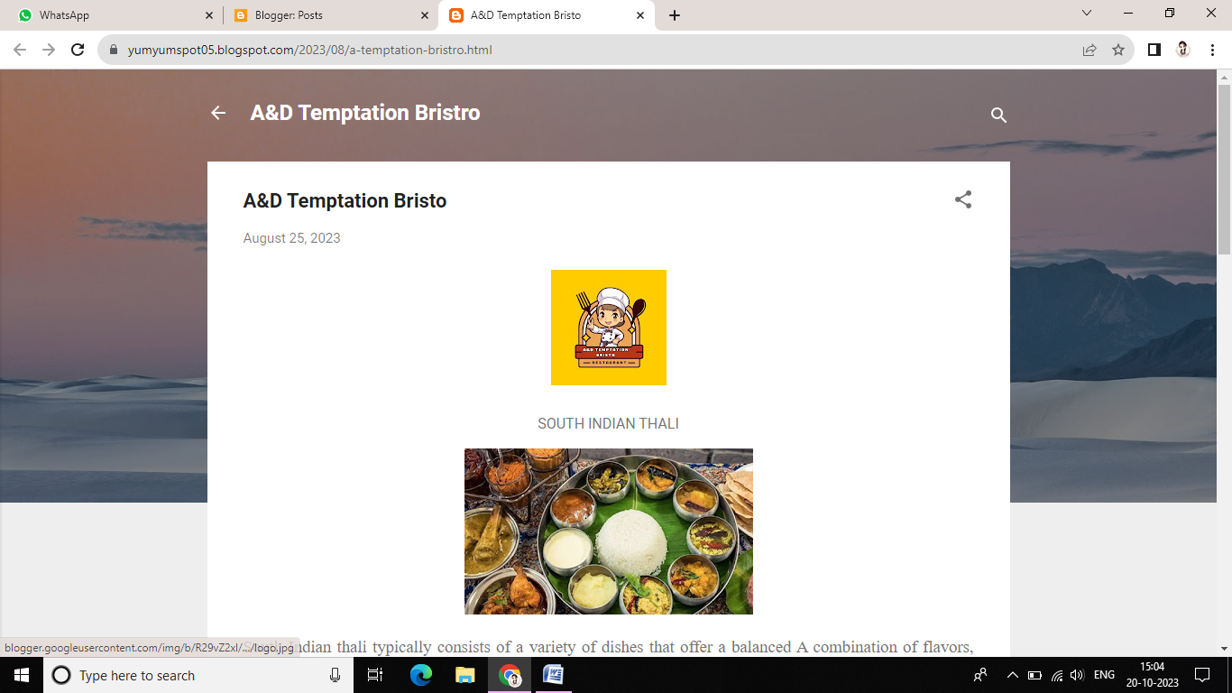

WordPress: <https://adtemptation.wordpress.com/2023/10/13/ad-temptation-bistro/>

